***Heaven’s Light is Our Guide***

**Rajshahi University of Engineering & Technology**



*Department of Electrical & Computer Engineering*

**Course Title:** Digital Signal Processing Sessional

**Course No. :** ECE 4124

**Submitted by:        Submitted to:**

**Name:** Anika Nawer       Hafsa Binte Kibria

**Roll:**    1810012       Lecturer

**Submission Date:** 15-05-2023Dept. of ECE

      RUET

**Experiment No:** 03

**Experiment Date:** 08.05.23

**Experiment Name:** (i) Study of Autocorrelation and implementation by MATLAB code.

(ii) Study of Cross-correlation and implementation by MATLAB code.

**Objective:** The main objective of this experiment is to learn about correlation and to implement autocorrelation and cross-correlation without using default function *xcorr().*

**Theory:** The correlation[1] of two functions or signals or waveforms is defined as the measure of similarity between those signals. There are two types of correlations –

* Autocorrelation
* Cross-correlation

**Autocorrelation:** The autocorrelation function is defined as the measure of similarity or coherence between a signal and its time delayed version. Therefore, the autocorrelation is the correlation of a signal with itself.

**Cross-correlation:** The cross-correlation between two different signals or functions or waveforms is defined as the measure of similarity or coherence between one signal and the time-delayed version of another signal. The cross-correlation between two different signals indicates the degree of relatedness between one signal and the time-delayed version of another signal.

**Required Platform:** MATLAB

**Code with figure:**

**i) Autocorrelation:**

clc ;

clear all ;

x=input ('x') ;

m1=length ( x ) ;

ln=m1+m1-1;

y=[x,zeros(1,(m1-1))];

n=ln;

while(n>=1)

r(ln-n+1)=0;

j=n;

i=m1;

while(i>=1 && j>=1)

r(ln-n+1)=r(ln-n+1)+x(i)*y(j);

j=j-1;

i=i-1;

end

n=n-1;

end

subplot(2,1,1);

stem(x);

title('signal x');

subplot(2,1,2);

stem(r);

title('autocorrelated signal');

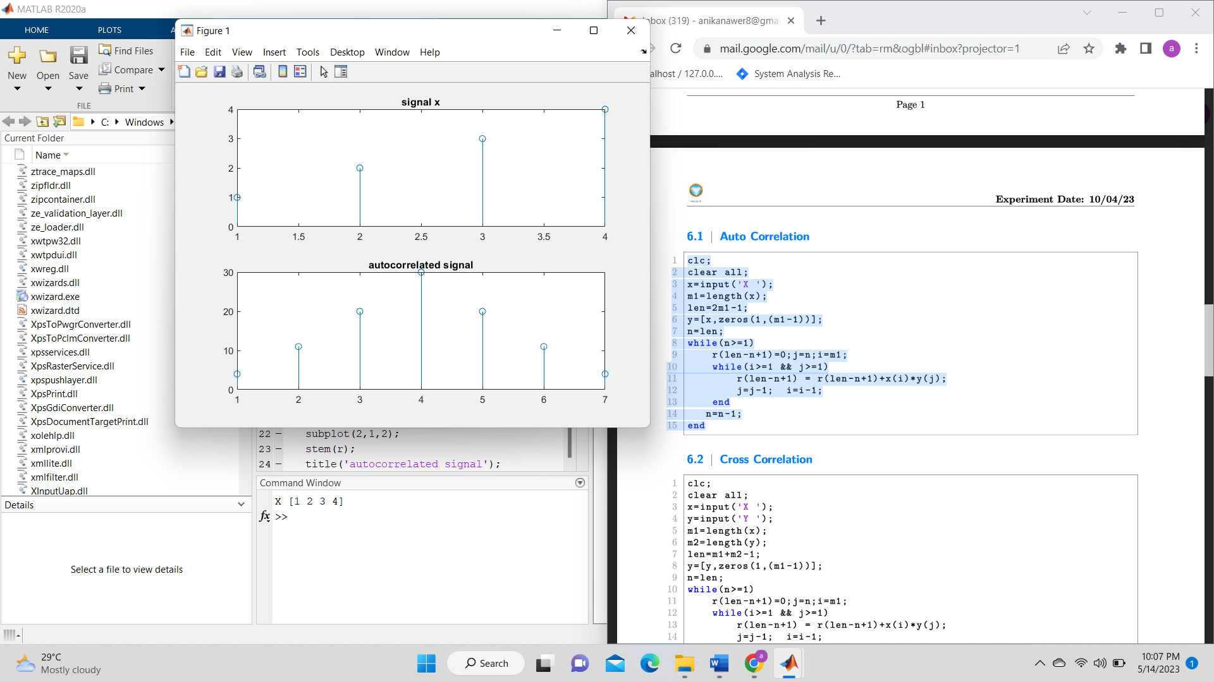

**ii) Cross-correlation:**

clc ;

clear all ;

x = input ('input signal X:') ;

y = input ('input signal Y:') ;

m1 = length ( x ) ;

m2 = length ( y ) ;

len = m1 + m2 -1;

y =[y,zeros(1,( m1 -1))];

n = len ;

while (n >=1)

r ( len - n +1) =0; j = n ; i = m1 ;

while (i >=1 && j >=1)

r ( len - n +1) = r ( len - n +1) + x ( i ) * y ( j ) ;

j =j -1; i =i -1;

end

n =n -1;

end

subplot(3,1,1);

stem(x);

title('signal x');

subplot(3,1,2);

stem(y);

title('signal y');

subplot(3,1,3);

stem(r);

title('Cross-correlated signal');

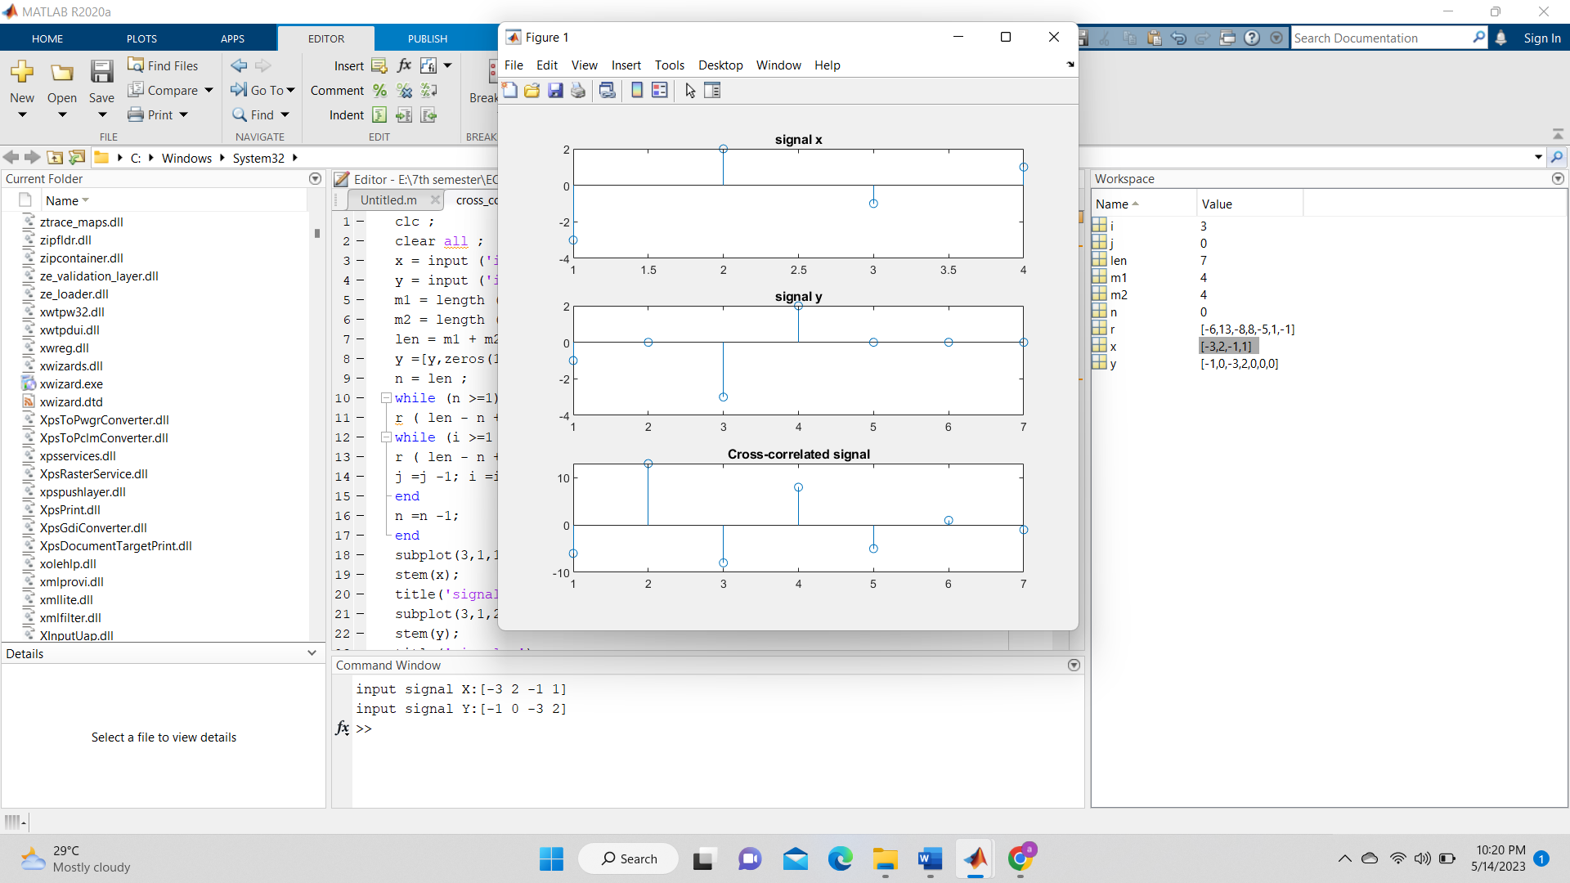

**Discussion:**

In this experiment we have implemented autocorrelation and cross-correlation without using default function ‘xcorr()’ and verified the result using default function ‘xcorr(). As we got same theoretical and experimental value so our experiment was successful without any error.

**Conclusion:** As all of our experimental values and calculated values according to theory was same, so our whole experiment was successful.

**References:**

[1]*“correlation*”,tutorialspoint,2023. [Online]. Available: <https://www.tutorialspoint.com/what-is-correlation-in-signals-and-systems>.[Accessed:14-May- 2023].